***Academic Education Sessions- 2021 AOTA INSPIRE***

* ***Wednesday April 7: AESIS Networking Reception; 4:15- 4:45 pm EST*** 
  + ***Click on the Exhibits tab at the top of the home page***
  + ***Scroll down to locate AOTA Central: Special Interest Sections & Membership***

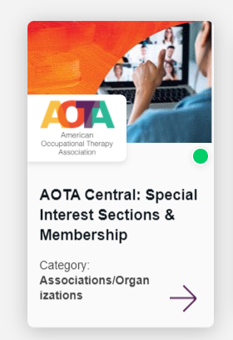

* + ***Enter General Room 1***
* ***Monday April 12: Academic Education Poster Session; 5:00-6:00 pm EST***

*Tuesday April 6*

|  |  |
| --- | --- |
| Session Title | Time (EST) |
| Short Course 101: Children with Autism Grow Up to Be Adults with Autism: What Higher Education Environments Can Do to Help Prepare Them for the Next Venture | 12:00- 1:00 pm |
| Short Course 113: Launching Interprofessional Student Interventions to Meet the Complex Health & Social Needs of Patients in Primary Care | 3:15- 4:!5 pm |
| Short Course 114: Developing Opportunities & Benefits for OT Practice & Education Through a Community Partnership With Habitat for Humanity | 3:15- 4:!5 pm |
| Seminar 002 (AOTA) Changing Practice Settings: Becoming an OT Educator |  |

*Wednesday April 7*

|  |  |
| --- | --- |
| Session Title | Time (EST) |
| Short Course 201: Achieving a Diversity of Thought: Implementing a Student-Led Implicit Bias Program for OT Students | 12:00- 1:00 pm |
| Short Course 213: Level II Fieldwork During a Pandemic: Leveraging ACOTE® Flexibility to Ensure Entry-Level Competency in Remote & Diverse Practice Settings | 3:15- 4:15 pm |
| Short Course 214: Demonstrating Cultural Responsiveness in the Classroom: Transgender Affirmative Care for OT Educators | 3:15- 4:15 pm |

*Thursday April 8*

|  |  |
| --- | --- |
| Session Title | Time (EST) |
| Short Course 301: College Student Mental Health: An Opportunity for OT | 12:00- 1:00 pm |
| Short Course 313: Pioneering Telehealth in Simulated & Patient Encounters in a Mixed-Methods Psychosocial Fieldwork Experience | 3:15- 4:15 pm |
| Short Course 314: Holistic Admissions Process & Outcomes in a Public Urban Research University | 3:15- 4:15 pm |

*Friday April 9*

|  |  |
| --- | --- |
| Session Title | Time (EST) |
| Short Course 401: Bridging the Gap: A Model Comprehensive Exam for Transitioning From Classroom to Fieldwork | 12:00-1:00 pm |
| Short Course 402: Facilitate Innovative Entry-Level Doctoral Capstones to Align with AOTA’s Vision 2025 Using Human-Centered Design Framework | 12:00- 1:00 pm |
| Short Course 413: Developing an Online Platform for Structured Case Clinical Simulation to Foster Clinical Competency & Evaluate Clinical Reasoning | 3:15- 4:15 pm |
| Short Course 414: Developing a Doctoral Capstone Project Process: Reflections at the 5-Year Mark | 3:!5- 4:15 pm |