|  |
| --- |
|  |

**You are cordially invited to:**

**DEPARTMENT OF OCCUPATIONAL THERAPY**

**YORK COLLEGE, CITY UNIVERSITY OF NEW YORK**

**SCHOOL OF HEALTH SCIENCE AND PROFESSIONAL PROGRAMS**

**13th ANNUAL OT RESEARCH VIRTUAL COLLOQUIUM**

**Presenting**

**Speaker: Dr. Joan Toglia**

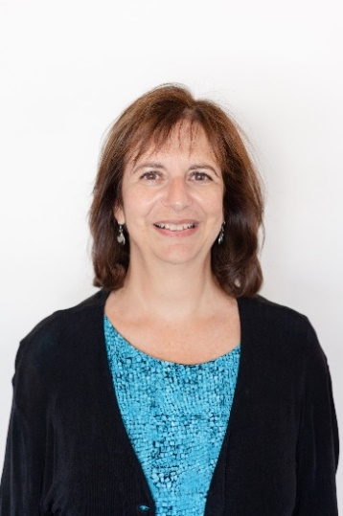

**Functional Cognitive Performance-Based Testing and The Weekly Calendar Planning Activity (WCPA): Broad Applications, Evidence, and Clinical Implications**



This presentation will discuss Functional Cognitive Performance Based assessment with a focus on the Weekly Calendar Planning Activity (WCPA). The WCPA has been used with ages 12 through older adults across a variety of populations (autism, ADHD, youth at risk, mental health, aging, ABI and other neurological conditions) with executive dysfunction.  The background, purpose, and format of the WCPA will be described and research evidence supporting broad clinical applications and utility will be highlighted along with implications for treatment.

**Joan Toglia, PhD, OTR/L, FAOTA** is Professor and Dean Emerita of the School of Health & Natural Sciences at Mercy College in Dobbs Ferry, New York.  She is also an Adjunct Clinical Professor of Cognitive Science in Rehabilitation Medicine at Weill Cornell Medical College.  Dr. Toglia has over 35 years of experience in Occupational Therapy and is internationally recognized as a leader in the rehabilitation of persons with cognitive deficits. Her research and extensive publications include a focus on metacognitive strategy intervention, assessment tools, and the relationship between cognitive impairments and occupational performance.

This is a free educational offering supported by York College, City University of New York for occupational therapists, students, rehabilitation and allied health community.  Please register at: <https://us02web.zoom.us/meeting/register/tZwrcuqrqT8vGNMm4oHz1jzr-w6URJlrtXex>

After registering, you will receive a confirmation email containing information about joining the meeting.