NBCOT Exam prep resources and tools
Please contribute to this document!

Tool | Notes (pros, cons, etc.)
NBCOT Study Pack (D’Youville will purchase for you)

NBCOT-Occupational Therapy – app. Gives you a question a day.

TherapyEd's National Occupational Therapy Review & Study Guide by Rita P. Fleming-Castaldy
https://www.therapyed.com/nbcots-otr-exam/
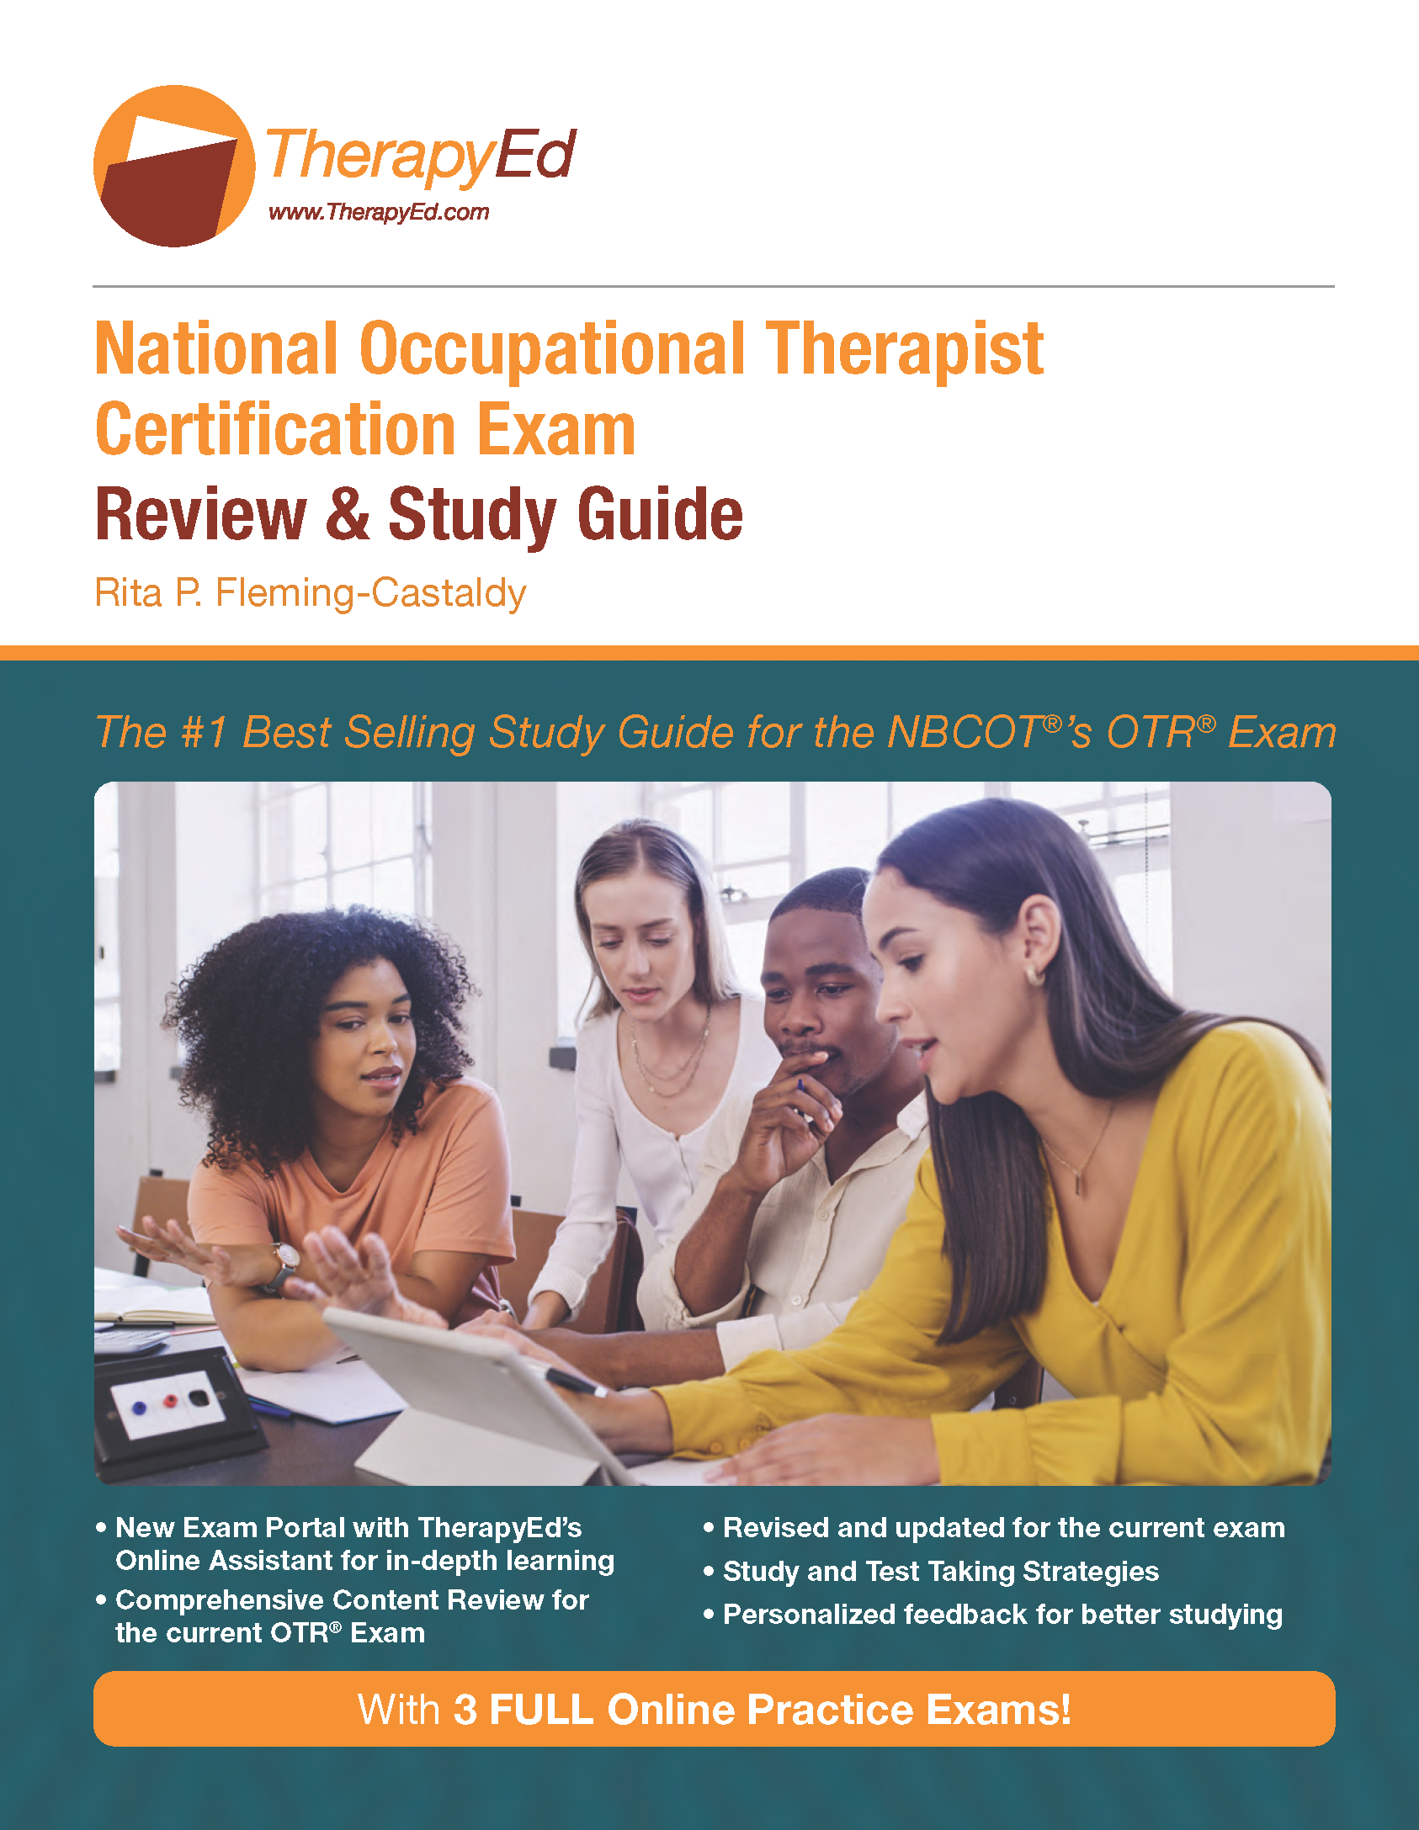

Text is $99.00 from publisher

Preparation course $330.00 in various locations and some virtual sessions.
There is one at UB April 27-28
Nazareth College April 25-26
Additional resources include:
- Online office hours
- One on one tutoring
- Cost is $75.00 an hour.
AOTA NBCOT Exam Prep ($149 for members and $209 for non members)
- https://www.aota.org/education/exam-prep
- 1,000 online self-assessment questions
- Create practice tests of any size around specific topics, choosing from multiple-choice and clinical simulation questions.
- Receive detailed feedback on each question.
- Check your progress by NBCOT® domain and by topic.
- Assess your progress against other users.
- Download topic outlines and test-taking hints.
- Subscriptions are for 1 year
- Downloadable pdfs at https://customerservice.aota.org/hc/en-us/articles/360016482153-Where-do-I-find-the-downloadable-pdf-s-

Pass the OT https://passtheot.com/ot/Web course:
- 19.99/week
- There are multiple packages with combinations of the web course and tutoring sessions
OT Miri https://www.otmiri.com/
- Miri Lee, OTD, OTR/L
- Website provides:
  - Free review videos
  - Study notes
  - NBCOT articles
  - There are also career guide and clinical tips

OT Exam Prepper http://www.otexamprepper.com/
- Free podcasts on various topics

Textbooks
- The tools that are available all provide you the source that the information came from.
- You should be going to the original source for more in-depth and detailed explanation.
Consider networking with others taking the exam through Facebook at
https://www.facebook.com/groups/aotaexamprep/

