[](http://prezi.com/n_dpw8txyfeh/?utm_campaign=share&utm_medium=copy)

Scholarship of Teaching and Learning Pre-Conference Institute! IN002

More Information about this *unique Institute copy and paste link for a Prezi*

<http://prezi.com/n_dpw8txyfeh/?utm_campaign=share&utm_medium=copy>

March 29, 12:00- 6:30

***100th Annual AOTA Conference***

**Philadelphia 2017**

The SoTL Leadership Team looks forward to getting to know you and learning about your Scholarship of Teaching and Learning Interests in Philly!

If you have questions please feel free to contact any of us:

Andrea Bilics [abilics@worcester.edu](mailto:abilics@worcester.edu)

Anne James [abjames@pugetsound.edu](mailto:abjames@pugetsound.edu)

Jyothi Gupta [jgupta@stkate.edu](mailto:jgupta@stkate.edu)

Lorrie George-Paschal [LorrieG@uca.edu](mailto:LorrieG@uca.edu)

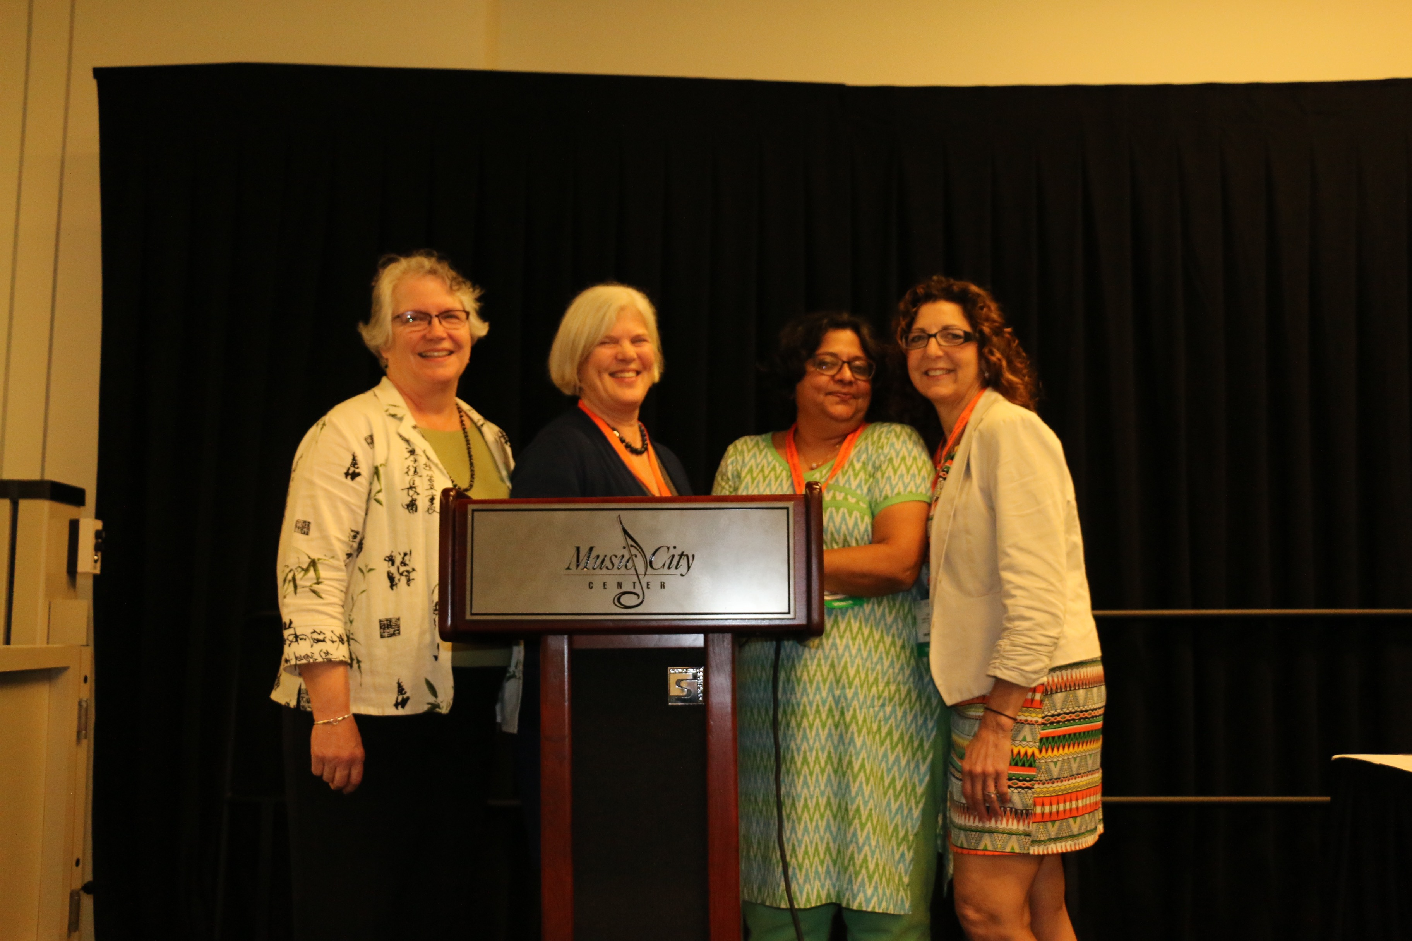

Our goal is to **help faculty** members interested in participating in a single site or multiple site research project related to teaching and learning at AOTA in 2017!

We will help you connect with a learning community related to your **primary** ‘scholarly’ teaching and learning question. Your mentor and learning community will oversee the design and provide support!

