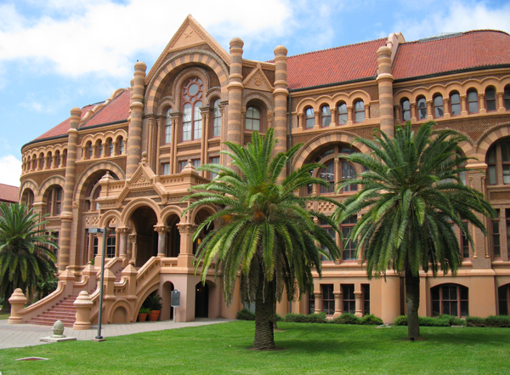

The School of Health Professions, Department of Occupational Therapy,
at The University of Texas Medical Branch at Galveston
is pleased to announce the development of a

Post-Professional Occupational Therapy Doctorate
Beginning January 2017
- This program is for the practicing occupational therapist who wants to increase clinical expertise and develop research, leadership, and management skills
- The program is designed to enable experienced occupational therapists to assume leadership roles and to serve as faculty in entry-level educational programs
- The program is primarily online with two visits to campus for onsite learning; it can be completed in six semesters while maintaining employment
- To be eligible for the program, students must have a Bachelor’s or Master’s entry-level degree in occupational therapy, three years of practice, and eligibility for licensure in the United States
- Students will be able to tailor the program beyond the required courses to achieve knowledge that will facilitate specific career goals
Program Director: April Cowan, OTR, OTD, CHT  Contact Person: Sharon McEachern  smceache@utmb.edu  409-772-3062 | 

